Meeting Notes January 30, 2013

# 1. Ant Color Codes

* Each colored ant has 4 colors.
* 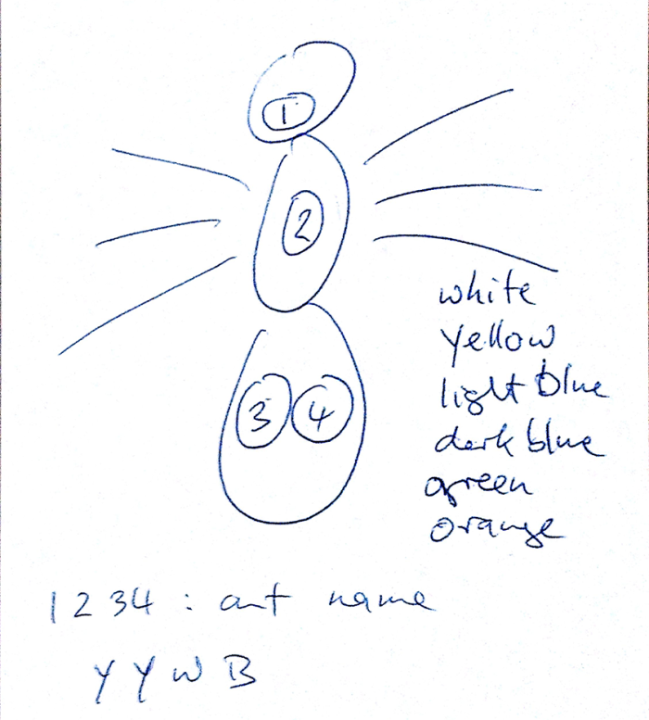These colors can be put together to form a name for the ant.
  + For instance YYWL is an ant with yellow on its head, yellow on its center, and then white followed by light blue on its end.
* Below is the list of colors and their respective codes:
  + W – white
  + Y – yellow
  + L – light blue
  + D – dark blue
  + G – green
  + O – orange
* When we ask the user to locate the starting positions for an ant, we can make the task more interesting by telling them to find the ant with a specific color code.
  + Perhaps we could time them as well, and show the player how long they took to find the ant compared to other players.

# 2. Research Questions

* Are the ants touching each other?
  + Is it mutual or directional?
  + Ants communicate by using their antennae to “taste” the other ants. They have around 50 different glands on their bodies just for communicating and making messages. This means that a big part of their bodies are just for making messages.

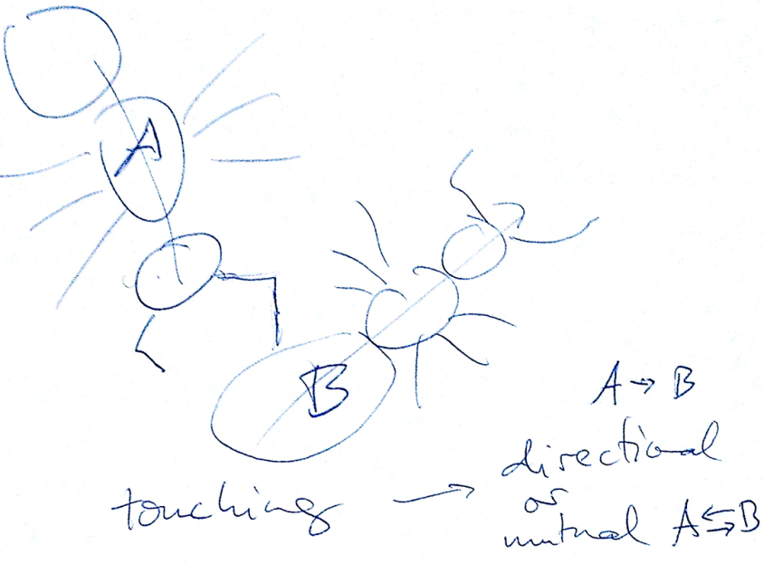

* Are the ants feeding each other?
  + This happens when they stand head-to-head for extended periods of time, at least a few seconds.
  + They will exchange food through their mouths.

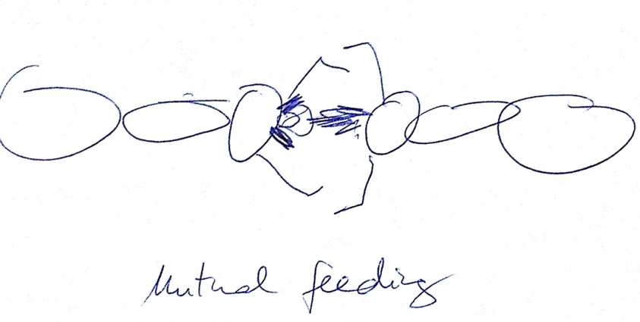

* Are the ants grooming each other?
  + We must do research on how ants groom each other in order to be able to distinguish it from touching/communicating.
* What types of ants are they?
  + Nurse ants tend to stay towards the middle of the colony, while warrior ants are more likely to be towards the outside.
* Do the color codes painted on their backs have an effect on the behavior of the ants?
  + We can compare the actions of the color coded ants to the non-color coded ones.
  + After a while, the paint will come off the ants, and we lose their identity after that.
* Why do some ants not appear to do any work?
  + Does removing the laziest ants on a colony have an effect?
* How do ants divide a task among themselves?
  + Why do some ants specialize rather than just doing what needs to be done?

# 3. Notes on Question: Why is Ant Research Interesting?

* The intelligence of the group: how do they solve large, complicated problems so easily?
  + Ex: searching over a large area, resolving conflicts, dividing up work.
* Ants have robust systems that can adjust easily to environment change and losing workers.
* Simple rules that can solve complex problems.
* Ants are some of the most cooperative animals. Because of that, they have the most sophisticated social behaviors.
* Watch the documentary *Ants – Nature’s Secret Power*: <http://www.hulu.com/watch/200303>

# 4. Miscellaneous Notes

* The game does not work on iPad, because Apple does not like Flash Player
  + We should look into getting an iPad and/or iPhone to test the game with.
  + The people who would most likely be interested in this game will probably prefer to play it on a tablet or mobile device.
* It’d be great if we could expose the player to different pieces of trivia about the ants
  + “The ant that you just finished tracking is most likely a nurse ant because….”
  + “There’s the queen ant!”
  + “Here’s the real size of the ants that you’ve been tracking” (show video or something that shows just how small the ants are compared to a person)
  + “You probably thought this ant was dead, but we know it’s not dead because ants usually leave the colony before dying. Or if it died within the colony, the other ants would have carried them away.”
* This way, players will actually get something meaningful out of playing the game by learning something new and having something to think about. It’d be great if we could design the entire game around this kind of experience, rather than around the idea of completing a task.